Antisemitic Propaganda Exercise:
What can we learn about the people who hate Jews? What are their prejudices and lies?
Cover of the antisemitic children’s book Trau keinem Fuchs auf gruener Heid und keinem Jud bein seinem Eid (Trust No Fox in the Green Meadow and No Jew on His Oath), published in 1936.

Answer these questions with your partner:
Deconstructing antisemitism:
1. What messages does this book cover send?
2. What stereotypes are used?
3. Why do you think it targets children?
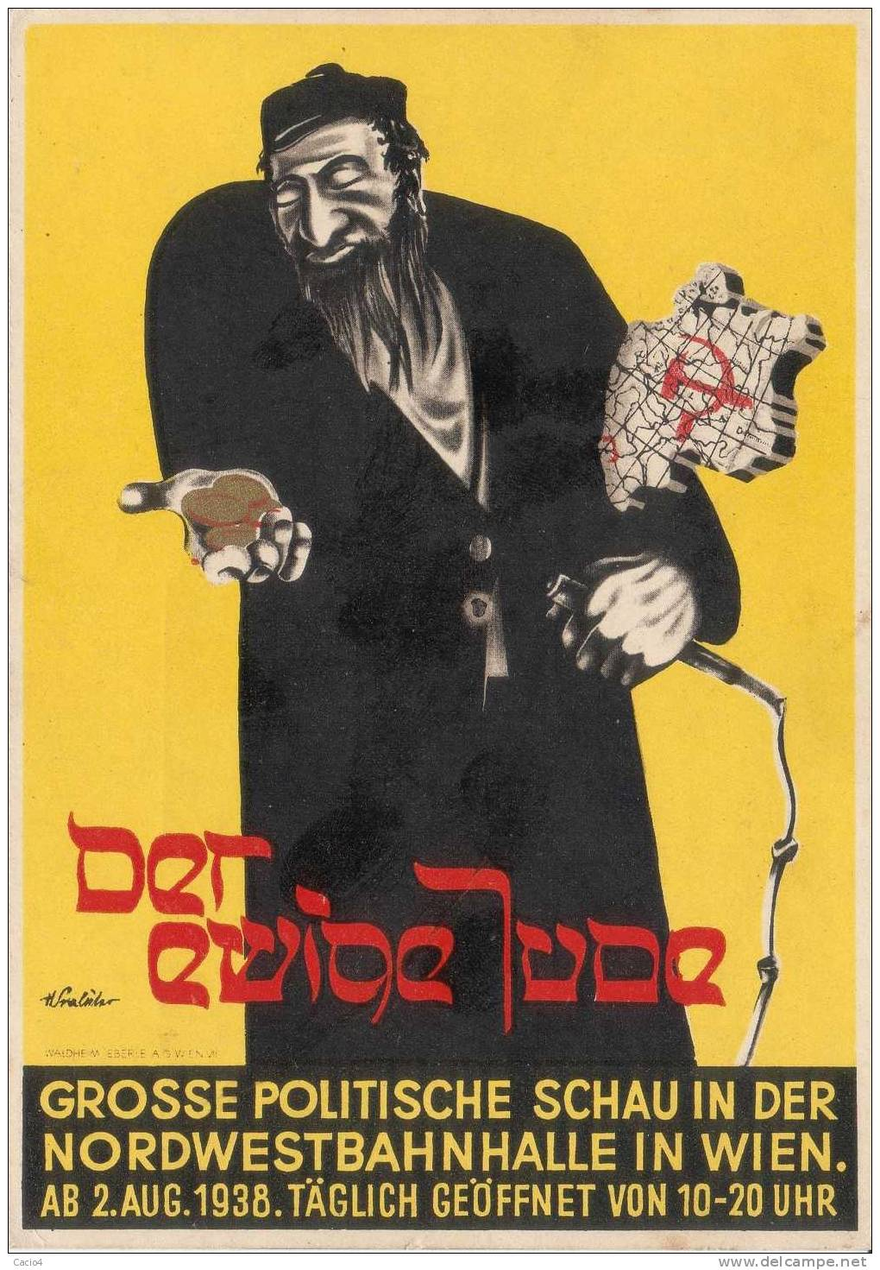
“The Eternal Jew” a movie from 1937.

Deconstructing antisemitism:
1. What messages does this movie poster send?
2. What stereotypes are used?
3. Why is it important to counter messages like these?
Against Jews and Their Lies (1542) by Martin Luther and reprinted in 1930s.
I had made up my mind to write no more either about the Jews or against them. But since I learned that these miserable and accursed people do not cease to lure to themselves even us, that is, the Christians, I have published this little book, so that I might be found among those who opposed such poisonous activities of the Jews who warned the Christians to be on their guard against them. May God help us. Amen.
Therefore be on your guard against the Jews, knowing that wherever they have their synagogues, nothing is found but a den of devils in which sheer selfglory, conceit, lies, blasphemy, and defaming of God and men are practiced most maliciously and veheming his eyes on them.
I brief, dear princes and lords, those of you who have Jews under your rule if my counsel does not please your, find better advice, so that you and we all can be rid of the unbearable, devilish burden of the Jews, lest we become guilty sharers before God in the lies, blasphemy, the defamation, and the curses which the mad Jewsindulge in so freely and wantonly against the person of our Lord Jesus Christ, this dear mother, all Christians, all authority, and ourselves.
However, we must avoid confirming them in their wanton lying, slandering, cursing, and defaming. Nor dare we make ourselves partners in their devilish ranting and raving by shielding and protecting them, by giving them food, drink, and shelter, or by other neighborly.
First to set fire to their synagogues or schools and to bury and cover with dirt whatever will not burn, so that no man will ever again see a stone or cinder of them. This is to be done in honor of our Lord and of Christendom, so that God might see that we are Christians,
Second, I advise that their houses also be razed and destroyed. This will bring home to them that they are not masters in our country, as they boast, but that they are living in exile and in captivity.
My essay, I hope, will furnish a Christian (who in any case has no desire to become a Jew) with enough material not only to defend himself against the blind, venomous Jews, but also to become the foe of the Jews' malice, lying, and cursing, and to understand not only that their belief is false but that they are surely possessed by all devils.

Deconstructing antisemitism:
1. Why did Luther write this slander? Why reprint it in the 1930s?
2. What messages does this publication send?
3. What impact will this have in the 1930s?

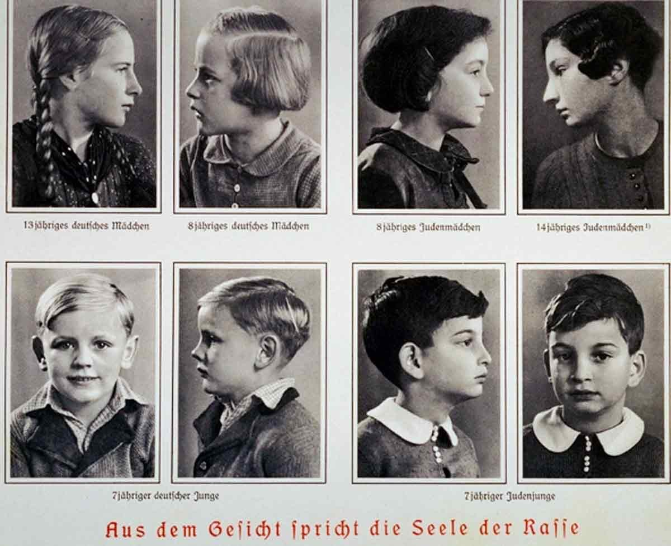

Deconstructing antisemitism:
1. Why did the Nazis print the above poster in the 1930s?
2. What messages does this publication send? What stereotypes does it create?
3. How is this different, and more dangerous, from the previous examples of antisemitism?

Antisemitic cartoon by Seppla (Josef Plank), showing an octopus with a Star of David over its head, 1938

Deconstructing antisemitism:
1. What messages does this cartoon send?
2. What stereotypes are used? What fears doe sit draw upon?
3. Why do you think the artist showed the world being attacked, rather than just
Germany or Europe?

OVERALL QUESTION: What can you do to counter such images and messages?

